**CSE 134B Homework 5**

**Final Execution and Optimizations**

**OverDex**

By Sherman Cheung and Trent Miller

**Table of Contents**

Demo Link

Architecture

Progressive Web App Development

File Organization

Screen Caps

Performance Testing

Concerns, Limitations, Caveats

Planned Features/Additions

## Demo Link

<https://overdex-f33ef.firebaseapp.com/>

## Architecture

OverDex uses Google’s Firebase service for hosting as well as database management on the backend. Firebase’s non-relational realtime database is used for all CRUD operations on OverDex, such as adding new Heroes and updating user stats.

On the frontend, OverDex is built using pure HTML, CSS and JavaScript. Early on in development we experimented with a couple libraries. We originally used Bootstrap for styling in addition to development in parallel using pure CSS. While Bootstrap was a powerful tool, it lacked components for some of our major usecases. For example, our main page included a cardview, but Bootstrap had no component for card views and working around this limitation slowed our development process. On the other hand, using pure CSS allowed us to customize our card view however we liked. For this reason, we decided to stick to vanilla CSS.

We also considered employing a JavaScript to ease our development burden, namely jQuery. However, after researching the library on StackOverflow and other sites, many of the highly voted answers were against the idea of using jQuery because of the size of the library. Since our app does not require JS too heavily outside of DOM manipulation, loading a large library like jQuery may not be worth it. It is unlikely that we would use the full power of the library. As a result, including such a large library would create a large burden for the user and may result in a poor user experience. In the end, we decided to use vanilla JavaScript.

## Progressive Web App Development

In order to make our site PWA compliant we added a manifest JSON file, which contains various attributes about our app, and a service worker. The service worker's main job is to cache static stuff so the app is not as reliant on the network. We were almost able to implement full offline support with the service worker, but could not finish everything necessary to make this happen. In the end, by making our app PWA compliant we saw a significant speedup in page load speeds and this will lead to a better mobile user experience.

## File Organization

OverDex uses the following file organization:

|-- HW5/

| |-- JS/

| |-- controller.js

| |-- dboperations.js

| |-- MinJS/

| |-- controller.js

| |-- dboperations.js

| |-- style/

| |-- styles.css

| |-- login.css

| |-- heropicker.css

| |-- bignoodletoo.ttf

| |-- HeroPortraits/

| |-- icons/

| |-- manifest.json

| |-- sw.js

| |-- login.html

| |-- index.html

| |-- Overwatch-Banner.png

| |-- firebase-debug.log

**JS** - This directory contains the JavaScript files. controller.js contains functions related to controlling the DOM manipulating content. It has functions for extracting user input from the DOM and then passing this information to the database. It also returns responses from the database and displays it on the DOM. dboperations.js contains functions used to interact with the Firebase database. This includes reading from and writing to the database.

**MinJS** - This directory contains the same files as the JS directory, but with all the JavaScript files minified. Minifiying files sends a smaller overall payload to the user while maintaining the same functionality. Another advantage is that it obfuscates code to make it more challenging for the enduser to understand.

**style** - This directory contains the CSS stylesheets. styles.css is the main stylesheet for index.html. heropicker.css is used for the Hero Picker component in index.html when the user wishes to add a new hero. Finally, login.css is used to style login.html. It also contains bignoodletoo.ttf which is the font used for Hero titles.

**manifest.json** - This file has all the necessary rules to make our app PWA compliant.

**sw.js** - This is our service worker. It caches static data and intercepts network requests so they look in the cache first.

**login.html** - This file provides the template for the login page. The user can login using either an email or their Google account. This authentication is provided by Firebase.

**index.html** - This file provides the template for the main page of the app. It displays the Hero Cards corresponding to the user’s favorite Heroes.

**HeroPortraits** - This directory contains a PNG picture of each Hero.

**icons** - This directory contains icons used for PWA. PWAs give users the option to add a webapp to their homepage. If a user chooses to do so, the icon will be one corresponding to a PNG in this directory.

**Overwatch-Banner.png** - This is the large banner with all the Heroes displayed at the top of the main page.

**firebase-debug.log** - This is a default log file that comes with Firebase. It can be used for debug logging.

## Screen Caps

Alternative album link: <http://imgur.com/a/0pytu>

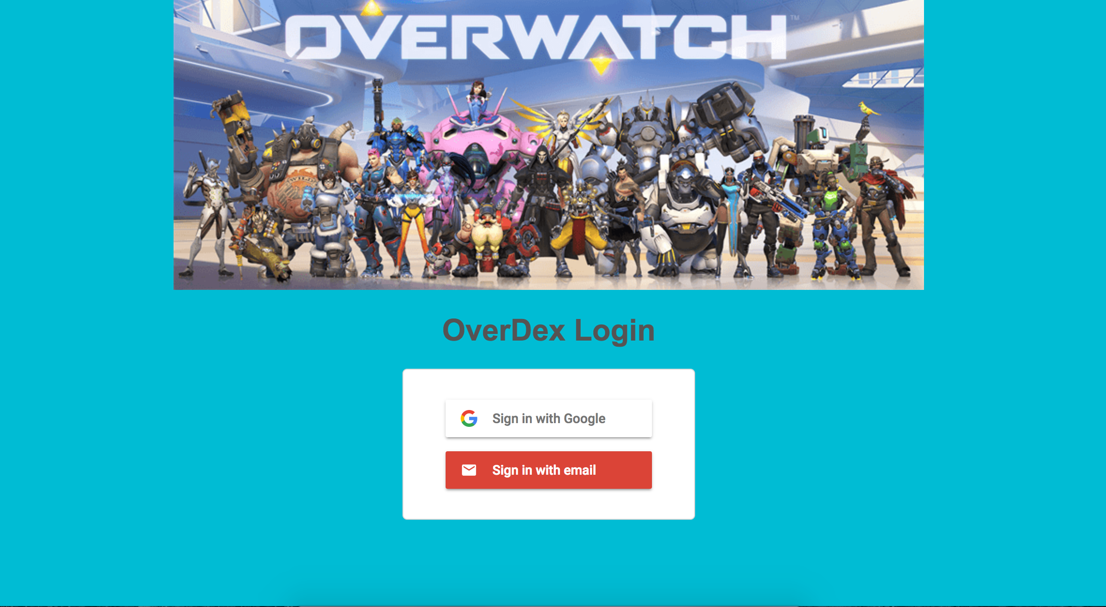

**Login Page - Desktop**

The Login Page is the main page used for logging in. The user can choose to either sign in with Google or sign in with an email. Because login pages are fairly common, it is important to follow convention with the design of this page so that the user is not surprised.

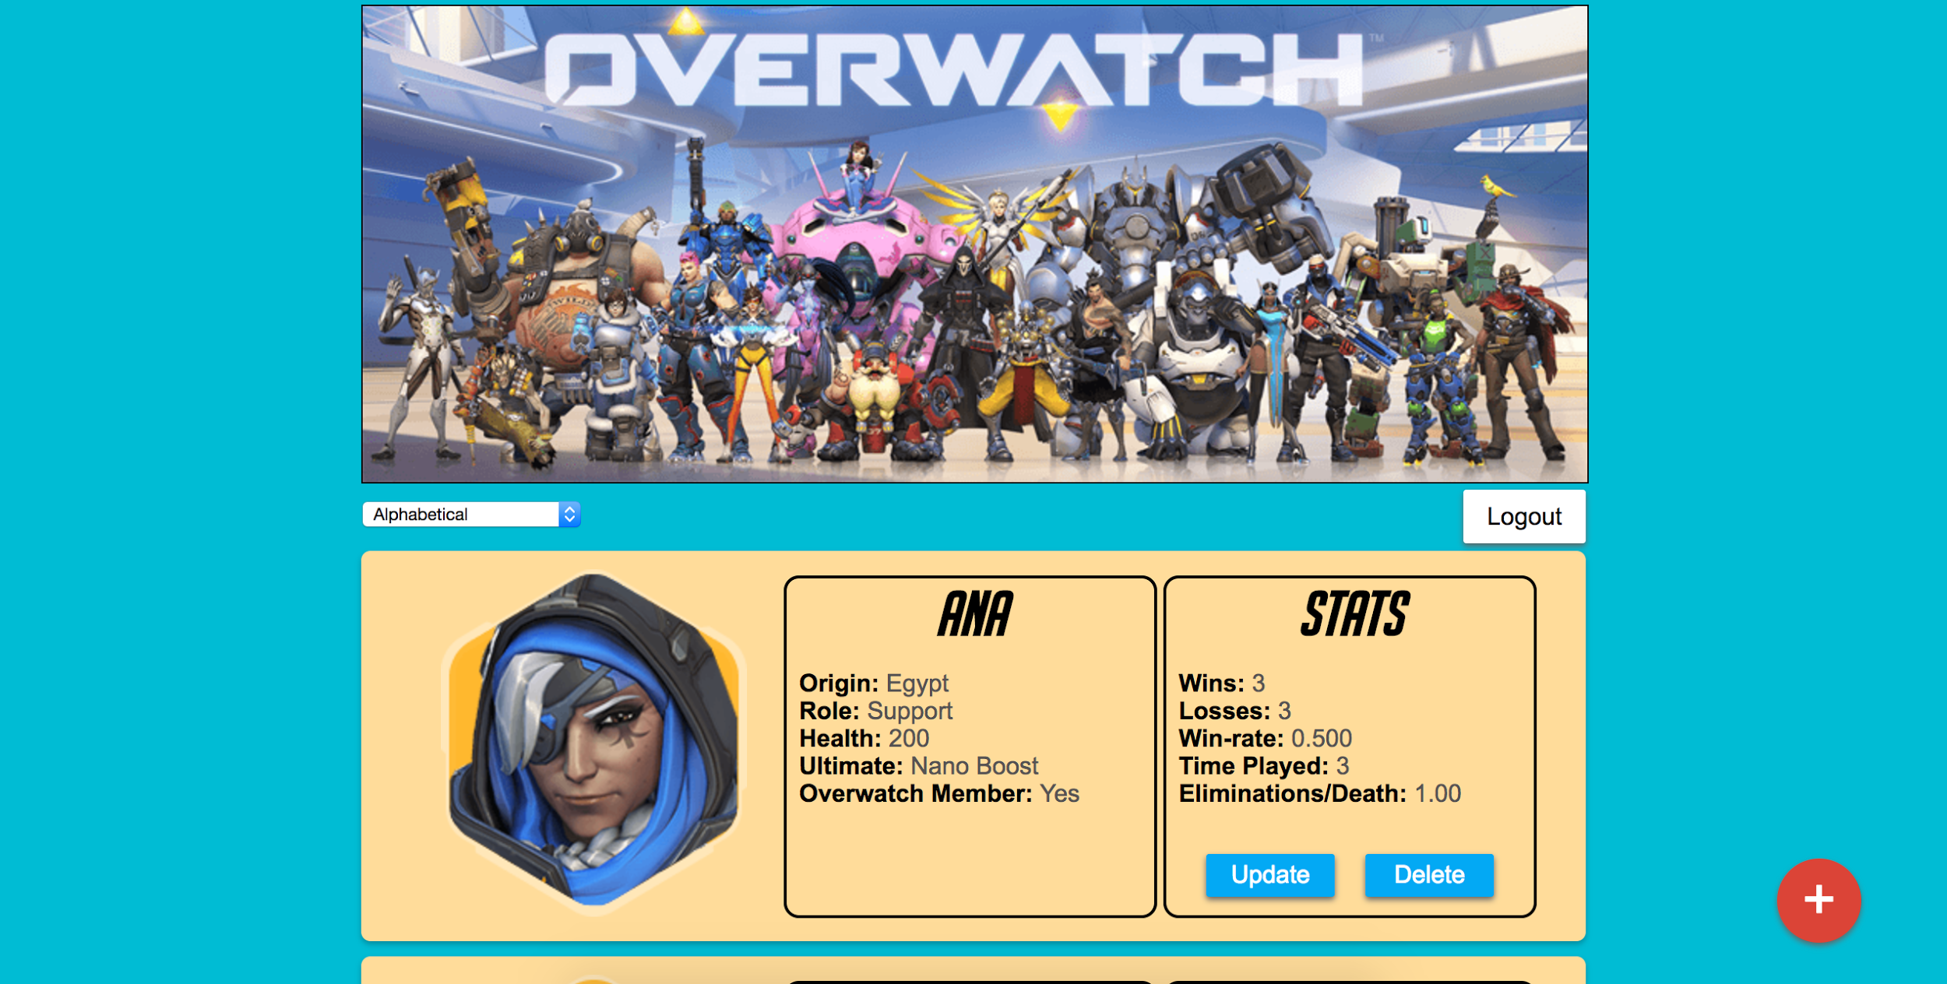

**Main Page - Desktop**

Our main page displays the user’s list of favorite Heroes. From here the user can click the red floating action button to add a new hero to their list, update their stats on a particular hero, or delete a hero from their favorites. They can also choose to sort heroes alphabetically or by winrate by using the dropdown in the top left. The user can also logout using the logout button in the top right.

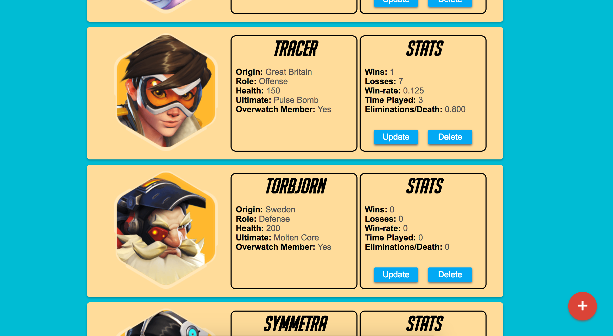

**Card View - Desktop**

Another view of the main page with more focus on the card view.

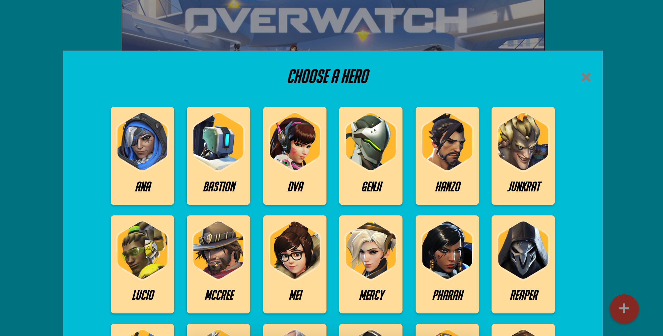

**Hero Picker - Desktop**

The Hero Picker is a modal that appears when the user clicks the floating action button from the main page. It allows them to add a new hero to their favorites. Clicking away from the modal or the exit on the top right will remove it.

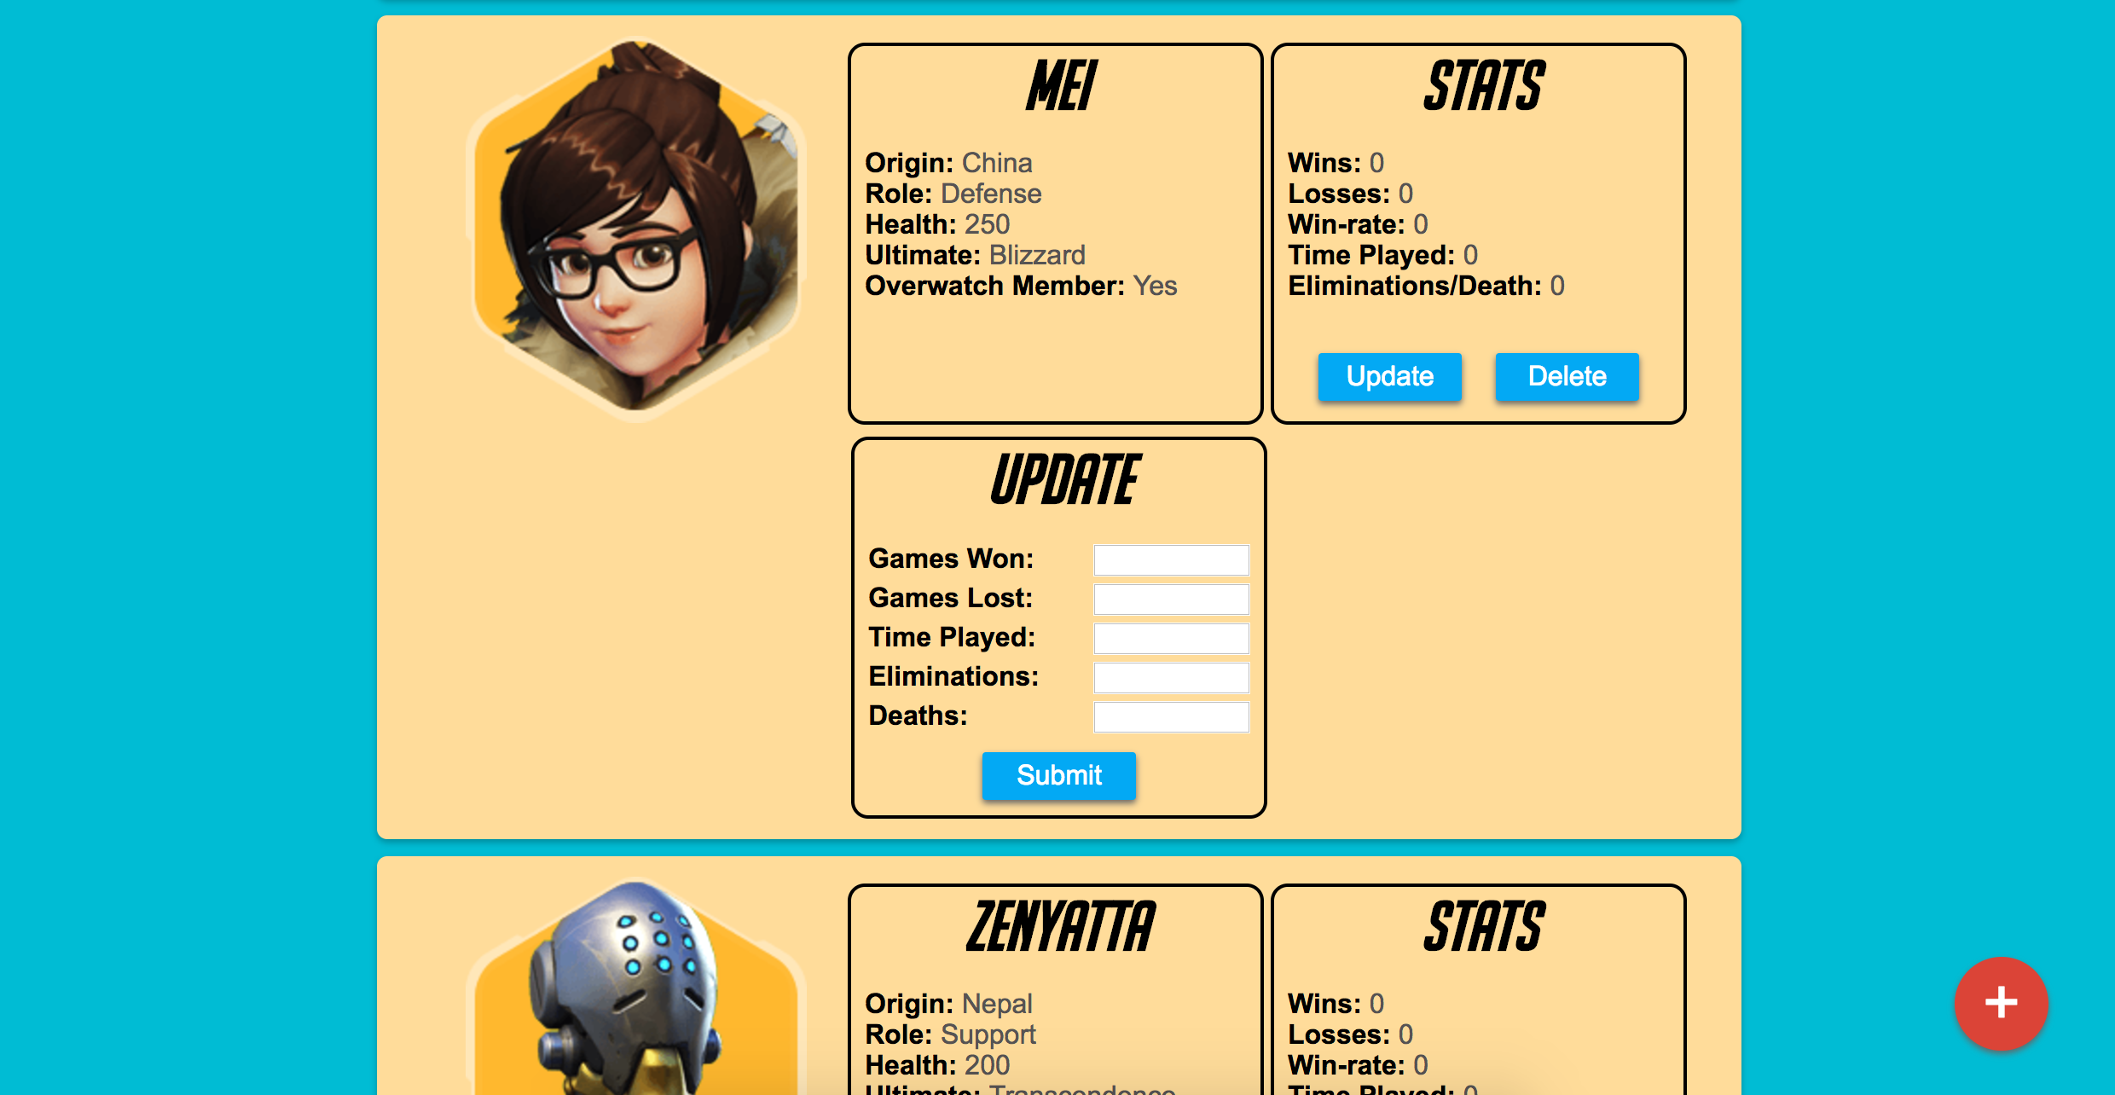

**Update Form - Desktop**

The Update Form appears when the user clicks the Update button under the Stats portion of a particular Hero’s card. This allows the user to update their stats based on their most recent play session. The stats submitted will be added to their cumulative stats and then displayed to the user.

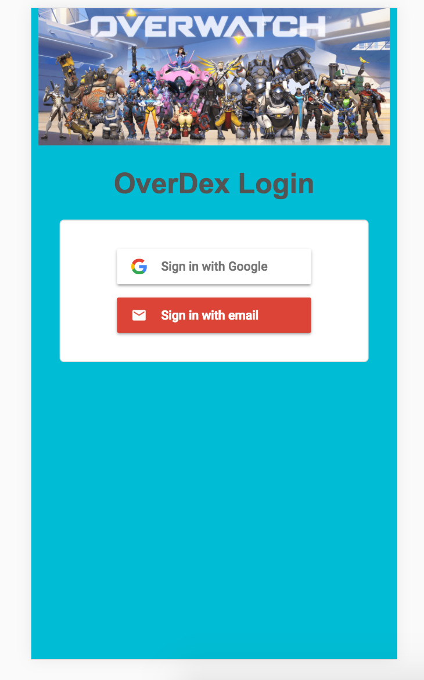

**Login Page - Mobile**

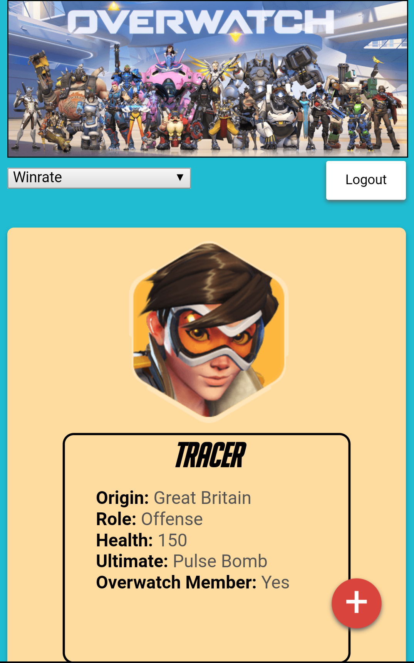

**Main Page - Mobile**

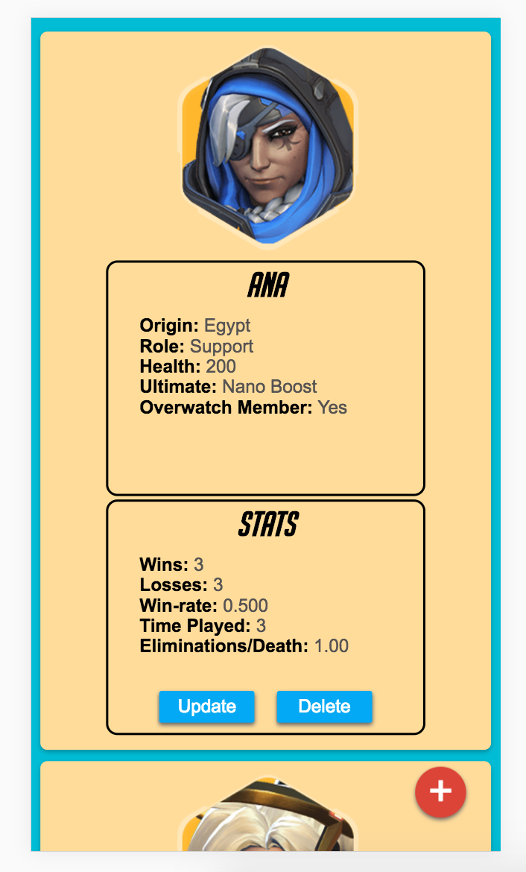

**Card View - Mobile**

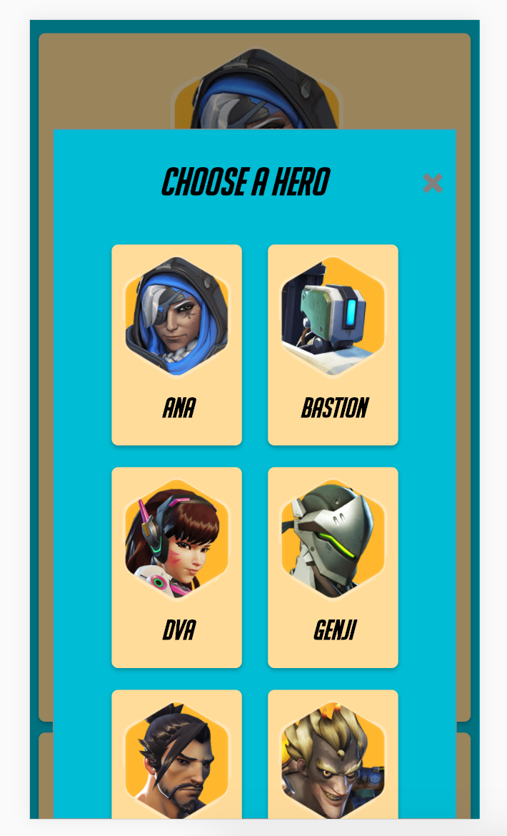

**Hero Picker - Mobile**

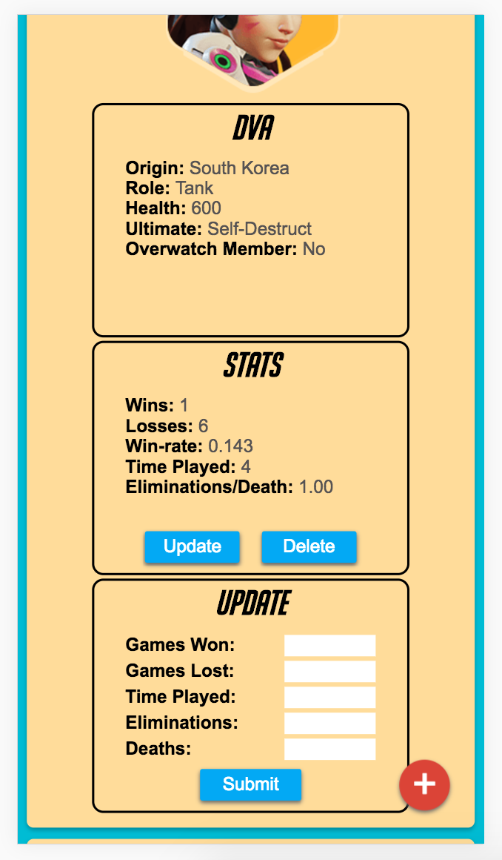

**Update Form - Mobile**

## Performance Testing

**Speed Without Service Worker**

Test Device: Android Phone

Network Throttle Speed: Regular 3G

Browser: Chrome for Android

1st load index.html: 2.40s

2nd load index.html: 2.10s

Without the service worker the speed between 1st load and 2nd load didn’t vary that much. The speedup we got on the second load was from the browser caching some of our data for us.

**Speed With Service Worker**

Test Device: Android Phone

Network Throttle Speed: Regular 3G

Browser: Chrome for Android

1st load index.html: 2.34s

2nd load index.html: 1.3s

Using the service worker our page loaded significantly faster. The service worker gave us a significant amount of control over what we can cache, and by utilizing this we saw a decrease in load time by almost a factor of 2 on the second page load.

**Score from webpagetest.org**

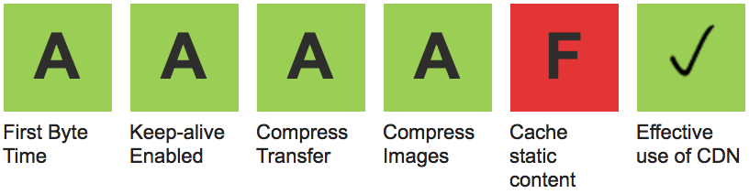

The reason we got an F for caching is because our caching is handled by our service worker but our service worker is only registered when the user is successfully logged in. Because webpagetest.org doesn’t have an account, nothing is cached.

## Concerns, Limitations, Caveats

OverDex is ready for submission, but it is by no means in its final form. We can certainly continue iterating and polishing it in the future. The app also has some limitations in its current form that we are well aware of. Namely, our performance can still be improved. While we worked hard to speed up our app throughout the development process and also employed Progressive Web App principles, we know that it can still be improved. Our main CSS stylesheet currently uses a lot of @media queries. This means we utilize the same stylesheet for both desktop and mobile. Consequently, our mobile users are burdened with having to load a large stylesheet meant for both desktop and mobile. This leads to increase load times and a worsened user experience.

## Planned Features/Additions

While we are ready to submit our OverDex web application now, there are still a few features that we would like to add in the future that we did not have time to implement in the current iteration.

**Input validation for Update Stats Form**

Currently, when updating their stats using the Update Stats Form, the user is able to input whatever data they please even though we are expecting integers. In the future, we would like to add input validation to prevent malicious inputs.

**Additional Sorting Methods ie Eliminations and Time Played**

We currently only allow the user to sort their favorites either alphabetically or by winrate. However, the user may wish to sort by eliminations or their time played on a Hero. This would improve the user experience and give them a better understanding of their stats.

**Confirmation banner for successful actions and warning banner for failure**

In the future, we would like to add a confirmation banner to indicate when the user has successfully completed an action. For example, adding a new Hero to favorites should display a temporary green banner at the top of the page indicating that the action was successful. Conversely, a failed action should display a red banner indicating that the action failed. Currently an alert dialogue is displayed when a user tried to add a Hero that is already in their favorites. This is not the best user experience and can be improved upon.

**Minify CSS and bundle files**

Currently, we are only minifying our JavaScript files. However, minifying our CSS files could also yield similar performance increases as it results in a smaller payload. We could also consider bundling our files together into a single CSS file and a single JS file which could result in a smaller transmission to the user.

**Quality of life improvements for user**

We have a few ideas for quality of life improvements for the user that we did not get around to. Namely, better placements of buttons or forms to make it easier for the user to interact with the site, a custom URL such as overdex.com instead of exposing our firebase URL, tracking more gameplay statistics in addition to the current ones, and creating a more mobile friendly interface such as swiping to delete a hero.